广东以色列理工学院科研楼液氮站采购项目
GTIIT research building liquid nitrogen station procurement project
- 项目信息：
Project Information:
- 项目名称：广东以色列理工学院科研楼液氮站采购项目
Project name: GTIIT research building liquid nitrogen station procurement project
- 项目内容：
Project Content:
- 为保障实验室足够高纯度氮气（99.999%）的供应要求，采用以租代购形式租赁一套氮气供气装置，包含液氮汽化装置，汇流排、管道等和4个195升低温绝热液氮瓶。供应商在对甲方提供的安装场地进行勘察后提供系统设计及施工。同时，负责该系统在租赁期内的所有运营，维护及保养工作。
In order to ensure sufficient supply of high-purity nitrogen (99.999%) for the laboratory, plan to lease a nitrogen gas supply system in the form of rental instead of purchase, including liquid nitrogen vaporization device, bus, pipe, etc., and 4 set of 195 liters of low-temperature insulated liquid nitrogen tanks. The supplier shall provide system design and construction after surveying the installation site provided by Party A. At the same time, responsible for all operation, maintenance and maintenance of the system during the lease period.
- 供应商需要负责约定租赁期间内系统相关的日常液氮供应，包括非工作日相关实验室的液氮供应服务，应急处置，包括不限于泄露处理，液氮供应等。液氮按实际用量支付，投标文件需提供收费明细。
The supplier shall be responsible for the daily supply of liquid nitrogen related to the system during the lease period, including the liquid nitrogen supply service of the relevant laboratory on non-working days, emergency treatment, including but not limited to leakage treatment, liquid nitrogen supply, etc. The liquid nitrogen shall be paid according to the actual amount, and the charge details shall be provided in the bidding documents.
- 租赁期满后系统所有权归甲方所有。
The ownership of the system shall be owned by Party A upon the expiration of the lease.

- 供应商资质条件：
Supplier qualification:
- 营业执照具备：工业气体制造、生产、销售；钢瓶及其切割，焊接工艺器具的销售；钢瓶维修及技术检验；
Business license: industrial gas manufacturing, production, sales; Sales of steel cylinders, cutting and welding equipment; Cylinder maintenance and technical inspection;
- 具备危险化学品经营许可证。
With hazardous chemical business license.
- 具备压缩及液化氮气安全生产许可证。
With compressed and liquefied nitrogen safety production license.
- 项目工期：建设期30天，租赁期3年。
Project duration: 30 days for construction and 3 years for lease.
- 租赁方案要求：
Requirements of leasing program:
- 租金自项目验收合格后正式投入使用起计，按季度支付。液氮费用根据实际用量按季度支付。
The rent shall be paid quarterly since the project is officially put into use after acceptance. Liquid nitrogen charges are paid quarterly based on actual usage.
- 每月租金最高支付6000元人民币，投标单位对本项目提供投标折扣率（例如：提供八折优惠，则折扣率为80%）。
The maximum monthly rental payment is RMB 6,000, and the tenderer will provide a bid discount rate for this project (for example, if a 20% discount is provided, the discount rate will be 80%).

- 采购需求：
Purchasing requirements:
- 供应商需要根据科研楼现有氮气的中央供气不足的情况，提供液氮汽化站设计方案，设计需要全面考虑可行性，安全性及经济效益性等要求。设计需要符合工业气体等国家相关设计标准，设计图纸需要获得校方确认后才进行项目施工。
The supplier shall provide the design scheme of the liquid nitrogen vaporization station according to the shortage of central nitrogen gas supply in the research building, and the design shall comprehensively consider the requirements of feasibility, safety and economic efficiency. The design should meet the relevant national design standards such as industrial gas, and the design drawings should be confirmed by Party A before construction.
- 供应商提供4 台标准液氮储罐及相关汽化器、管路等的设计、制造、运输和安装；
The supplier provides the design, manufacture, transportation and installation of 4 standard liquid nitrogen storage tanks and related carburetors and pipelines;
- 供应商提供4 台标准液氮储罐应接受国家有关规定的压力容器生产制造的监督
和检验；
Four standard liquid nitrogen storage tanks provided by the supplier shall accept the supervision and inspection of the production and manufacturing of pressure vessels stipulated by the state;
- 供应商提供液氮储罐的压力容器操作手册、 产品质量证明书、产品合格证以及各种检验报告，已取得使用登记证且在检测有效期内；
The supplier shall provide the operating manual of the pressure vessel of the liquid nitrogen storage tank, the product quality certificate, the product qualification certificate and various inspection reports, and have obtained the use registration certificate and are within the validity period of the inspection;
- 供应商提供详细的液氮储罐流程图（包括标准配备的储罐外管路等）以及系统示意图；
The supplier shall provide the detailed flow chart of the liquid nitrogen storage tank (including the standard external pipeline of the storage tank, etc.) and the system diagram;
- 供应商提供液氮储罐的各种主要技术参数。如：材质（包括内胆、外壳和管路、面漆种类和标号）、隔热真空度、设计压力、气密性试验压力、安全阀开启压力、日蒸发率、漏放气速率、内胆尺寸、外形尺寸、重量等；
The supplier should provide main technical parameters of the liquid nitrogen storage tank. Such as: material (including inner liner, shell and pipeline, paint type and label), heat insulation vacuum degree, design pressure, air tightness test pressure, safety valve opening pressure, daily evaporation rate, leakage rate, inner liner size, overall size, weight, etc.;
- 供应商提供液氮储罐的出入口接口资料；
The supplier shall provide the inlet and outlet interface information of the liquid nitrogen storage tank;
- 每台液氮储罐除本地具有压力、液位指示外，液氮罐具有手动和自动两种泄压方式，并以自动泄压为主。压力报警装置需要链接中央报警系统。
In addition to the local pressure and liquid level indication for each liquid nitrogen storage tank, the liquid nitrogen tank has two modes of manual and automatic pressure relief, and automatic pressure relief is mainly used. The pressure alarm device needs to be linked to the central alarm system.
- 相关所有管路（含汽化器管路）均为 316L 不锈钢 BA 管。
All relevant pipes (including carburetor pipes) are 316L stainless steel BA pipes.

- 参考的安装条件及初步方案图纸：
Reference installation conditions and preliminary scheme drawings:
- 安装位置
Installation position

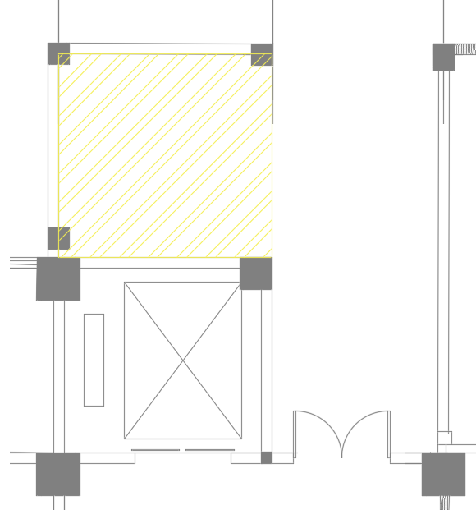

- 初步设计方案：
Preliminary design scheme:

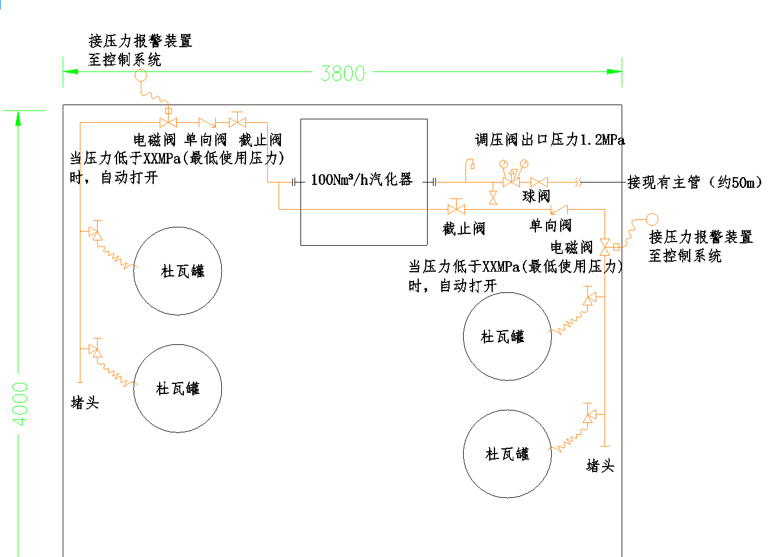
Dewar tank
Dewar tank
Dewar tank
Dewar tank
Plug
Plug
Connect pressure alarm device to control system
To the existing main pipeline（50m）
Pressure regulator outlet 1.2Mpa
vaporize
Connect pressure alarm device to control system
When the pressure is below the set pressure, the valve opens automatically

评分标准Scoring standard
评分项目  Scoring item | 商务部分  Business patr | 技术部分  Technical part | 价格部分  Price part | 合计  Total
分值score | 30分 | 40分 | 30分 | 100分
商务部分 Business part
序号Item | 评审分项Rating content | 分值  Score | 评审标准 Evaluation criteria
1 | 服务方案Service scheme | 16分 | 投标人根据要求提供系统租赁服务方案。综合对比进行评审：  - 总体服务方案清晰，经济效益性，可行性较强，得16分。  - 总体服务方案一般，经济效益性，可行性一般，得10分。  - 总体服务方案较差，经济效益较低，可行性一般，得4分。  - 不提供不得分。  The bidder shall provide the system leasing service scheme upon request. Comprehensive comparison review:  (1) The overall service plan is clear, economic efficiency, and strong feasibility, scoring 16 points.  (2) The overall service plan is average, economic efficiency and feasibility are average, and get 10 points.  (3) The overall service plan is poor, the economic benefits are low, and the feasibility is average, scoring 4 points.  (4) Do not provide no points.
2 | 项目业绩Project performance | 8分 | 投标人近三年以来成功实施的同类业绩，提供项目业绩的每个得2分；最高得8分。（需提供已完成项目的合同复印件或中标通知书加盖公章，项目时间以合同签订日期为准）  The bidder's successful implementation of similar performance in the past three years, each project performance is awarded 2 points; The highest score is 8 points. (The copy of the contract of the completed project or the notice of acceptance shall be affixed with the official seal, and the project time shall be subject to the contract signing date)
3 | 售后服务After-sales service | 6分 | 投标人承诺的维修和服务响应时间：  - 收到采购人通知（电话或书面）后2小时内（含2小时）响应并上门服务，得6分；  - 收到采购人通知（电话或书面）后超过2小时但4小时内（含4小时）响应并上门服务，得4分；  - 收到采购人通知（电话或书面）后超过4小时但8小时内（含8小时）响应并上门服务，得2分；  - 其余情况不得分。  - 注：需提供承诺函原件（格式自拟）并加盖公章。  The bidder's commitment to maintance and service response time:  (1) Response and on-site service within 2 hours (including 2 hours) after receiving the purchaser's notice (telephone or written), score 6 points;  (2) More than 2 hours after receiving the buyer's notice (telephone or written) but within 4 hours (including 4 hours) to respond and on-site service, score 4 points;  (3) More than 4 hours after receiving the purchaser's notice (telephone or written) but within 8 hours (including 8 hours) to respond and on-site service, score 2 points;  (4) No points are given for other cases.  Note: The original letter of commitment (in its own format) should be provided and stamped with official seal.
合计 |  | 30分
技术部分 Technical part
序号Item | 评审分项Rating content | 分值  Score | 评审标准 Evaluation criteria
1 | 组织方案Organization plan | 15分 | 提供完整施工人员组织架构，进度计划，资源配置计划，安全管理措施，质量管理措施，环境管理措施等。综合对比进行评审：  1.总体思路清晰，组织方案完整合理，可操作性强的，得15分；  2.总体思路一般，组织方案基本合理，可操作性一般，得10分；  3.总体思路差，组织方案基本合理，可操作性差的，得5分。  4.不提供不得分。  provides a complete construction personnel organization, schedule, resource allocation plan, safety management measures, quality management measures, environmental management measures, etc. Comprehensive comparison review:  1. The overall plan is clear, the organization plan is complete and reasonable, and the operability is strong, scoring 15 points;  2. The overall plan is general, the organization plan is basically reasonable, and the operability is general, scoring 10 points;  3. The overall plan is poor, the organization plan is basically reasonable, and the operability is poor, score 5 points.  4. No offer, no score.
2 | 施工方案Construction plan | 15分 | 提供完整施工方案以及各专业深化设计图纸。根据提供资料完善程度评审：  1.总体思路清晰明确，图纸设计完整合理，得15分；  2.总体思路一般，图纸设计基本合理，得10分；  3.总体思路差，图纸不完整，可操作性差的，得5分。  4.不提供不得分。  Provide a complete construction plan and each professional deepening design drawings. Based on the degree of completeness of the information provided:  1. The overall plan is clear, and the drawing design is complete and reasonable, scoring 15 points;  2. The overall plan is general, and the drawing design is basically reasonable, scoring 10 points;  3. The overall plan is poor, the drawings are incomplete, and the operability is poor, get 5 points.  4. No offer, no score.
3 | 安装、调试、培训措施Installation, commissioning, training measures | 10分 | 1.安装、调试、培训措施详细、完整、科学、合理、针对性强，对相关风险分析透切，并制定了切实可行的防护方案，得10分；  2.安装、调试、培训措施一般，对相关风险分析一般，防护方案一般，得6分；  3.安装、调试、培训措施较差，对相关风险分析较差，防护方案较差，得2分；  5.不提供不得分。  1. Installation, commissioning and training measures are detailed, complete, scientific, reasonable and highly targeted, and have thoroughly analyzed relevant risks and formulated feasible protection plans, scoring 10 points;  2. Average installation, commissioning and training measures, average analysis of related risks, and average protection plan, scoring 6 points;  3. Poor installation, commissioning and training measures, poor analysis of related risks and poor protection schemes, scoring 2 points;  5. No offer, no score.
合计 |  | 40分

价格部分 Price part
评分项目  Rating content | 评分标准  Scoring standard
价格  Price | 价格分是以满足招标文件要求且投标价格最低的投标报价（投标折扣率）为评标基准价，其他投标人的价格分则按比例算出。  价格分＝（评标基准价/投标报价）×30  The price score shall be based on the bid quotation (bid discount rate) that meets the requirements of the bidding documents and has the lowest bid price as the benchmark price for bid evaluation, and the price score of other bidders shall be calculated in proportion.  Price score = (benchmark bid evaluation price/tender offer) ×30

注：各评委按规定的范围内进行量化打分，并统计总分
Note: Each judge will give a score within the prescribed range and count the total score

